

Assignment 1

MLB_02.01_12

Online Teacher Trainer

Software Processing Model -I

**Assignment 1 Cover Sheet**

**IT1060 – Software Process Modeling year 01**

**Semister II**



|  |  |
| --- | --- |
| **PROJECT ID** | MLB_02.01_12 |
| **CASE STUDY NAME** | Online Teacher Trainer |
| **CAMPUS/CENTER** | SLIIT/Malabe |

**Group Details:**

|  |  |  |
| --- | --- | --- |
|  | **Student Registration Number** | **Student Name** |
| **1** | IT21819506 | V.Abilaxshan |
| **2** | IT21828898 | S.Thusithan |
| **3** | IT21809460 | M.Lavanya |
| **4** | IT21598500 | Abiramy.K |

**Assignment 1 Certify Sheet**

**IT1060 – Software Process Modeling year 01**

**Semester II**

|  |
| --- |
| **We hereby certify,**  ☑ The attached is our own work and no further changes will be made.  🗹 We have contributed in this assignment to the best of our ability.  And we understand,  ☑ We may be subject to student discipline processes in the event of an act of academic misconduct by us including an act of plagiarism or cheating |

|  |  |  |  |  |
| --- | --- | --- | --- | --- |
|  | **Student Name** | **Student Registration Number** | **Date** | **Signature** |
| **1** | V.Abilaxshan | IT21819506 | 10/10/2022 |  |
| **2** | S.Thusithan | IT21828898 | 10/10/2022 |  |
| **3** | M.Lavanya | IT21809460 | 10/10/2022 |  |
| **4** | Abiramy . K | IT21598500 | 10/10/2022 |  |

**Group Details:**

**Introduction**

An Online teacher trainer system is the new evolution in teacher training progress

Because any time at anywhere you can train your knowledge and can access how many courses you want. Our New guru online teacher trainer is specially aimed to the teachers and those who are in training, who are willing to study new courses and more to handle new information technology usable things, we update our system day to day. And we have our 24-hour customer hotline. We clarify every detail to our users and we are the international reorganized online teacher trainer system .

It help teacher to achieve their target and moreover it helps to teach in high universities too. Our new guru decreases your pressure of searching for good quality study courses and gives the best and standard courses in your hand .

**Assumption**

We have decided to introduce this “Teacher trainer app” in order to develop the knowledge of the teachers through an online platform. So that, it is able to access easily rather than going for physical learning ways. It also helps to save time and able to learn anytime.

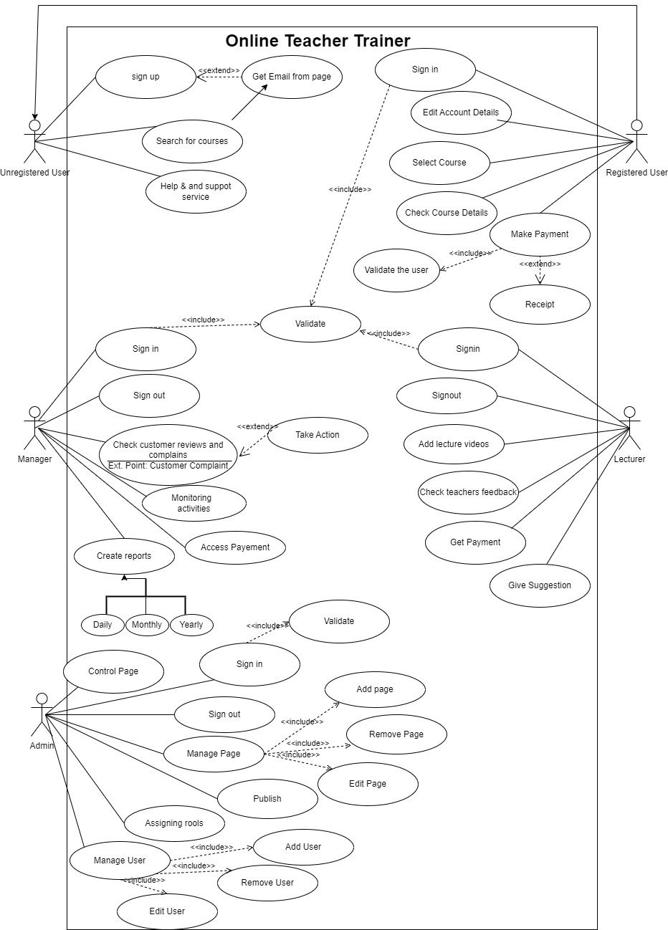

**IT21809460 M. Lavanya**

**Section Worked on:**

* Designed use cases for the "unregistered user" actor.
* Designed for use cases

**Special Contribution:**

* A study of case studies. Provide relevant information about the unregistered user.

**Challenges faced:**

* It was difficult for me to select the most relevant use cases for the unregistered user, gathering information about the use cases was a challenge for me.

|  |  |
| --- | --- |
| Number | OTT5 |
| Name | Register |
| Summary | User create new account |
| Priority | 1 |
| Pre-condition | The user is on the home page or on any page of the Online Teacher Trainer website |
| Post-condition | User register a new account |
| Primary Actor | Unregistered user(unregister teacher) |
| Main Scenario | |  |  | | --- | --- | | Step | Action | | 1 | Go to the online teacher trainer  (show the home page) | | 2 | Click on’Sign up’ icon on the web page | | 3 | The system redirects the user to the registration page | | 4 | Enter the following information on the webpage as required by the user.   * First name * Last name * Email * Phone number * Password | | 5 | Agree to the term & condition | | 6 | User click on submit form button | | 7 | An email will be sent to you, please follow the instruction on the e-mail and activate your account | | 8 | Open the user confirmation email and click the activation link | | 9 | User is redirected to a new page. the following message will be displayed” your account has been activated successfully” | |
| Extension | |  |  | | --- | --- | | Step | Branching Action | | 4a | If the username and password are already in use, a system will display a message and prompt the user to enter another username and password. | | 4a | The user did not fill in the required fields. System highlights show empty fields in red color and the following message.  "Fill Required Fields" | | 4c | If the invalid email address is given, display an error message to “This email address is invalid. Please enter a valid email address.” | | 5a | The user does not accept the terms and conditions. The system displays the following message.  "Please accept the terms and conditions". | | 7a | The user email was not received. Click on User "Click here to send an email." | | 8a | The activation link has expired because the user is taking too long. The user is redirected to a new page and the following message is displayed. “Your activation link has expired. Please request a new connection here. | |

**Section Worked on:**

* Designed use cases for the "registered user" actor.
* Designed for use cases

**Special Contribution:**

* A study of case studies. Provide relevant information about the registered user.
* Supporting team members while doing the use case diagram.

|  |  |
| --- | --- |
| Number | OTT 4 |
| Name | Course registration |
| Summary | Add the course |
| Priority | 2 |
| Pre-condition | Only paid lessons are training |
| Post-condition | The user add the course |
| primary Actor | registered user(register teacher) |
| Main Scenario | |  |  | | --- | --- | | Step | Action | | 1 | go to the teacher trainer website | | 2 | Click on ‘sign in’ icon on the web page | | 3 | The system redirects the user to sign in page | | 4 | enter your Email and password | | 5 | Click on sign in icon after display show dashboard | | 6 | display the courses | | 7 | Select the course. | | 8 | Complete your payment  ‘receive a receipt’ | | 9 | Let’s start your course | | 10 | Keep practicing | | 11 | Complete your course | | 12 | Get the certificate | |
| Extension | |  |  | | --- | --- | | Step | Branching Action | | 8a | If you don't get the receipt then visit the help site | |

**IT21819506 V . Abilaxshan**

**section worked on** :

* contribute to drawing the use case . Drew the use case scenario for admin page,
* wrote introduction to this use case diagram.

**special contribution on:**

* Writing the introduction and checked errors , guiding the team members to wright way to achieve the completion of the assignment
* drawing the use case diagram using software to complete the use case diagram.
* explain the use case diagrams concepts to team members.

**challenges Faced :**

* Difficult to select most suitable Use cases for the admin user,
* Gathering information about use cases was a challenge for me.

|  |  |
| --- | --- |
| Number | OTT1 |
| Name | admin |
| Summary | publish courses |
| Priority | 5 |
| Pre-condition | admin needs to login his/her document |
| Post-condition | admin can check the update details in the system |
| Primary Actor | admin |
| Main Scenario | |  |  | | --- | --- | | Step | Action | | 1 | search the online teacher trainer web site | | 2 | sign in as admin | | 3 | Create courses | | 4 | Add the courses | | 5 | Check the course details | | 6 | Publish the course details | | 7 | sign out as admin | |
| Extension | |  |  | | --- | --- | | Step | Branching Action | | 2a | Log in to the system using username and password | | 2b | Reset the password if it forgot and log in again to the system. | | 5a | If the courses are not accurate correct the course details. | | 5b | after correction publish the courses | |

**IT21828898 S . Thusithan**

**section worked on** :

* Contribute to drawing the use case.
* Draw a use case scenario for the Lecturer.

**special contribution on:**

* Writing the assumption of the website for online teacher trainer.
* Help to complete the use case diagram with draw io and help others to draw use case diagram.

**challenges Faced :**

* It was challenging to select the best use case to Lecturer
* I evaluated whether the use cases in the above diagram are accurate or not.

|  |  |
| --- | --- |
| Number | OTT 3 |
| Name | Lecturer |
| Summary | Add the videos |
| Priority | 3 |
| Pre-condition | Lecturer needs to sign in his or her account |
| Post-condition | Lecturer can check the lecture videos and suggestions |
| primary Actor | Lecturer |
| Main Scenario | |  |  | | --- | --- | | Step | Action | | 1 | Go to the Online Teacher Trainer | | 2 | Click on ‘sign in’ icon on the web page | | 3 | Sign in as Lecturer | | 4 | System check the Lecturer account details | | 5 | Lecturer upload the videos and tutorials | | 6 | Lecturer can check the videos which are uploaded | | 7 | Lecturer check the suggestions of the teachers | | 8 | Sign out as Lecturer | |
| Extension | |  |  | | --- | --- | | Step | Branching Action | | 5a | If lecture videos are not working then go to help center | |

**IT215298500 Abiramy .K**

**section worked on** :

* Drew the use case diagram by using draw io software.
* Design the use case diagram together with the team members.
* Defined the use case, Generalization, include and extend of the Manager.

**special contribution on:**

* Shared Ideas among the Group members about the Use cases.
* Explained to team members what is use case and how to draw them.
* Found some errors on use case of the team members and fix them.
* Worked as a team to combine the whole use case diagram.

**challenges Faced :**

* Difficult to find the relations among the use cases.
* As am new to draw.io ,it was little bit hard to draw use case diagram

|  |  |  |
| --- | --- | --- |
| **Number** | OTT2 | |
| **Name** | Create Report | |
| **Summary** | Create the annual report for the company | |
| **Priority** | 5 | |
| **Preconditions** | Enter in to the Database | |
| **Post conditions** | Successfully Create the report | |
| **Primary Actor (s)** | Manager | |
| **Trigger** | Decide to create report using user’s data | |
| **Main Scenario** | **Step** | **Action** |
|  | **1** | Login to the database |
| **2** | Enter in to the User Data Folder |
| **3** | Gather all user data files |
| **4** | Manager send user data to Staff to categorize the data according to the job title |
| **5** | Then, Manager send categorized data to the Assistant |
| **6** | Assistant return the created charts and graphs to the Manager |
| **7** | Till the Manager satisfied, Assistant modifies the charts and graphs |
| **8** | Once the manager satisfied, Manager create report |
| **9** | Manager add content, context and meaning to the report |
| **10** | Manager check the final report |
| **11** | Once the Manager satisfied with the report, Manager send the final annual report to the Admin |
| **12** | Admin publish the annual report which received from Manager |
| **Extensions** | **1a** | System asks to enter username and password |
|  | **1b** | System asks to reenter the password, if the password is incorrect |
| **2a** | System will display “Empty Folder”, if the folder is empty |
| **9a** | System will display “Enable editing” prompt |
| **11a** | System will ask “Enter Email address” to send the report |
| **12a** | System will ask “Do you want to publish?” when update the report |